## Browsing for Movie (With Sign Up/Sign In)

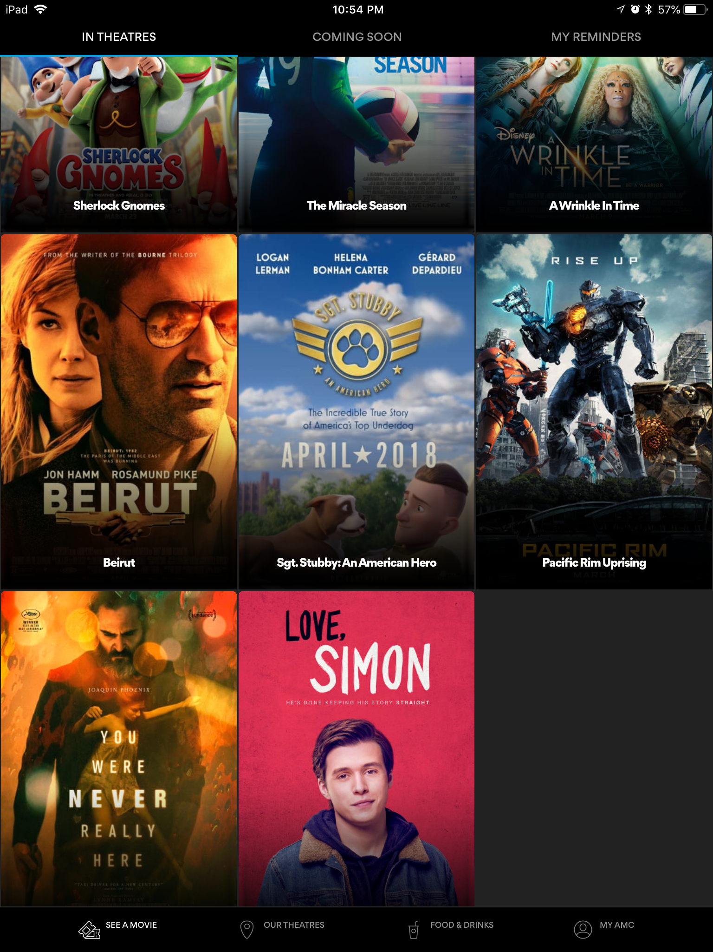

### Input Domain

​

The user doesn’t need to input anything for choosing a movie. However, the application requires to know the location of the user, so that will be considered the input. The user may also choose from theaters close to his/her location after providing a city or area code (Only works in USA). Boundary values aren’t present in this feature, however, equivalence partitioning is possible. The equivalence partitioning include: theaters close to user and theaters not close to user.

|  |  |  |
| --- | --- | --- |
| **Input Value Description** | **Steps to Take** | **Explanation of Expected Outputs** |
| Input: Current Location  Description: This theater is auto-selected from the user’s location obtained by the application and the user expects to choose a theater in that location. | 1. Select movie in logged In screen 2. Look/Choose Theater options | Expected Output: App shows movies in nearby theaters  Explanation: The app detects this location and display theaters in the area only. |
| Input: 100000  Description: The user may enter an invalid zip code | 1. Select movie in logged In screen 2. Look/Choose Theater options 3. Select choose location 4. Enter zip code | Expected Output: Error Message  Explanation: Invalid zip code. |
| Input: 95112  Description: The user inputs a valid zip code | 1. Select movie in logged In screen 2. Look/Choose Theater options 3. Select choose location 4. Enter zip code | Expected Output: Theater list shown on screen  Explanation: The user enters a valid zip code which now shows all theaters close to the area in the zip code |
| Input: New Delhi  Description: The user may enter a city which does not partner with AMC | 1. Select movie in logged In screen 2. Look/Choose Theater options 3. Select choose location 4. Enter city name | Expected Output: Error Message  Explanation: City does not partner with AMC theaters |
| Input: San Jose  Description: The user inputs a valid city name | 1. Select movie in logged In screen 2. Look/Choose Theater options 3. Select choose location 4. Enter city name | Expected Output: Theater list shown on screen  Explanation: The user enters a valid city name which now shows all theaters close to the area in the city |
| Input: shdfhg  Description: The user inputs an invalid city name | 1. Select movie in logged In screen 2. Look/Choose Theater options 3. Select choose location 4. Enter city name | Expected Output: Error Message  Explanation: Not a valid city name |

### Equivalence Partitioning Table

|  |  |
| --- | --- |
| **Equivalence Partitioning Class** | **Result** |
| Movie theaters close to user location | Theaters appear on the list |
| Movie theaters not close to user location | Theaters don’t appear on the list |

### Test Cases

|  |  |  |  |  |  |
| --- | --- | --- | --- | --- | --- |
| # | Test Case | Inputs | Expected Output | Actual Output | Test Pass/Fail |
| 1 | User is in the location and expects a theater in the location | Location: Current Location | Show theaters around that area only | -Century 20 Great Mall -AMC Mercado 20 -Camera 3  -CineArts at Santana Row -AMC Eastridge 15 ... | Pass |
| 2 | User is in a location but wants a theater in a different location | Location: 100000 | Error Message | Error Message | Pass |
|  | User is in a location but wants a theater in a different location | Location: 95112 | Show theaters around that area only | -Century 20 Great Mall -AMC Mercado 20 -Camera 3  -CineArts at Santana Row -AMC Eastridge 15 ... | Pass |
| 3 | User inputs an city name outside of USA | Location: New Delhi, India | Error Message | -Century 20 Great Mall -AMC Mercado 20 -Camera 3  -CineArts at Santana Row -AMC Eastridge 15 ... | Fail |
| 4 | User doesn’t allow the app to know his/her location | Location: None | Show message asking to allow to know location | “You must enable your GPS to use MoviePass” | Pass |
| 5 | User inputs an invalid location | Location: shdfhg | Error Message | Error Message | Pass |

## 